SỞ GIÁO DỤC VÀ ĐÀO TẠO  TỈNH ĐỒNG NAI | KỲ THI TUYỂN SINH VÀO LỚP 10  NĂM HỌC 2026-2027  MÔN: TIẾNG ANH  Thời gian làm bài: 60 phút (không kể thời gian phát đề)  (Đề thi này gồm 04 trang, có 37 câu)
  ĐỀ THAM KHẢO
Họ và tên thí sinh: SBD:
Chữ ký giám thị 1: Chữ ký giám thị 2:

I. MULTIPLE-CHOICE SECTION (7.5 points)
Choose the letter (A, B, C or D) to indicate the correct answer to each of the following questions.
1. _________ Sahara is often considered to be _________ largest desert in the world.
A. The / the B. A/ a C. A/ the D. The / a
2. If you _________ harder, you can win the race.
A. trains B. train C. trained D. will train
3. Would you mind _________ your radio down a little please?
A. turn B. turning C. to turn D. turned
4. I dislike littering. Do you know that it _________ the natural beauty here?
A. reaches B. climbs C. explores D. spoils
5. _________ we arrived late, we didn't miss the first part of the speech.
A. But B. Therefore C. Because D. Though
6. The website my brother came _________ has methods to improve his grammar.
A. across B. down C. back D. over
Choose the letter (A, B, C or D) to indicate the word whose underlined part differs from the other three in pronunciation in the following question.
7. A. promise B. surprise C. because D. amuse
Choose the letter (A, B, C or D) to indicate the word that differs from the other three in the position of primary stress in the following question.
8. A. parade B. problem C. reduce D. believe
Choose the letter (A, B, C or D) to indicate the underlined part that needs correction in each of the following questions.
9. The woman which always wears white dresses is the principal of our school.
A. which B. wears C. is D. of
10. These are his blue gloves; her are on the desk.
A. his B. gloves C. her D. on
Complete the conversation between David and his mum. Choose the correct letter (A-G). There are TWO extra letters you do not need to use.
David: Did you go to Australia when you were young, Mum?
Mum: Yes, I did! I was only 21 when I went there.
David: How long were you there?
Mum: (11) ______________________________________________________
David: Really? And who did you go with?
Mum: (12) ______________________________________________________
David: Where did you stay?
Mum: (13) ______________________________________________________
David: That’s great. And what did you do there?
Mum: (14) ______________________________________________________
David: Did you enjoy it?
Mum: (15) ______________________________________________________

- Oh, for about five weeks.
- Yes, I did. Tom loved it too.
- My friend Tom – we had great fun!
- You’re welcome! Please stay with us.
- Lots of things – one was camel riding!
- Tom’s uncle lives in a large house in Sydney. We were with him for a few weeks.
- Pardon? Tom didn’t go!
Choose the letter (A, B, C or D) to indicate the best arrangement of utterances or sentences to make a meaningful exchange or text in each of the following questions.
16.
a. Helen: Thank you.
b. Jenny: Go straight for two blocks, then turn right.
c. Helen: How do I get to the post office?
A. b-c-a B. a-b-c C. c-b-a D. c-a-b
17. Hi Tom,
I hope you’re fine. I need your help with something for school.
a. I know you did a great presentation on this, so maybe you have some tips for me.
b. I chose to talk about natural wonders because I think they are very interesting.
c. Do you have any advice on how to make my talk better?
d. I have to give a presentation in front of the class next week.
Write soon, Lucy
A. d – b – a – c B. b – d – a – c
C. d – a – b – c D. b – a – d – c
Read the following passage. Choose the letter (A, B, C or D) to indicate the correct word or phrase that best fits each of the numbered blanks.
Vietnamese customs
What should you do when you visit a different country? It's important to know their customs and you need to respect the local people. Read on to (18) _________ about some customs in Vietnam.
Greetings
Most people greet each other by shaking hands or bowing their heads slightly with a smile.
Eating and drinking
It’s important to wait (19) _________ the oldest person at the table to start eating before you take a bite. This custom shows that the local people really respect the elderly. Also, never place your chopsticks standing straight up in your bowl of rice; it's extremely rude.
Giving and receiving gifts
It's polite to accept a gift, (20) _____ you shouldn't refuse if someone offers you one. You should also ask the giver whether you can open a wrapped gift as soon as you receive it. If someone invites you to their home, you should (21) _________ a gift to the host like food or fruit.
Body language
Don't cross your (22) _________ or stand with your hands on your hips; it is impolite in Vietnam.
18. A. find B. follow C. learn D. get
19. A. at B. in C. for D. of
20. A. but B. because C. though D. so
21. A. offer B. to offer C. offering D. offered
22. A. hips B. arms C. heads D. noses
Read the passage and choose the letter (A, B, C or D) to indicate the correct answer to each of the following questions.
MISSING OUT?
All your friends have gone to a party. You can’t go because you have homework, but you can’t stop checking your phone. Have you ever been in this situation? Then perhaps you have FOMO - Fear of Missing Out.
“Sometimes I see a picture of some friends online,” explains Lucas, 16. “They’re doing something amazing, like surfing or snorkeling. It makes me unhappy. My friends are having fun and I’m not!”
About 25% of teenagers say that they get this feeling, but there’s another, far better feeling: JOMO - the joy of missing out!
Grace, 18, has learned to feel JOMO. “In the past, I never stayed in. But I wasn’t in control of my life, and other people were organizing it for me! When I finally understood this, I made changes. Now, I only go out occasionally and spend more time on my interests. I’m writing my own novel, and I’ve never felt happier!”
Dr. Stella Taylor, a psychologist, says social media makes FOMO worse. “It makes other people’s lives interesting and our own lives feel boring,” she says. So how can we learn to feel JOMO?
“Remember that you are in control of your life,” says Dr. Taylor. “When you’re older, you won’t remember those boring parties. You’ll think about the time you wasted! With JOMO, you’ll have more time for hobbies you enjoy, and you’ll feel much happier!”
Right! It’s time to put down your phone and find your pajamas. How about some TV?

23. When you have FOMO, you _________.
A. don’t want to see your friends B. worry about your homework
C. want to do what other people are doing D. can’t find your phone
24. About 25% of teenagers _________.
A. have experienced JOMO B. don’t know what FOMO is
C. have had FOMO D. have never missed a party
25. The word “interests” in paragraph 4 is CLOSEST in meaning to _________.
A. jobs B. pastimes C. assignments D. duties
26. The word “it” in paragraph 5 refers to _________.
A. a psychologist B. social media C. a novel D. a party
27. Dr. Taylor says that _________.
A. we’ll go to more boring parties in the future
B. we won’t worry about the parties we missed
C. we won’t have time for hobbies
D. we’ll spend more time watching TV

Read the texts and choose the letter (A, B, C or D) to indicate the correct answer to each of the following questions.

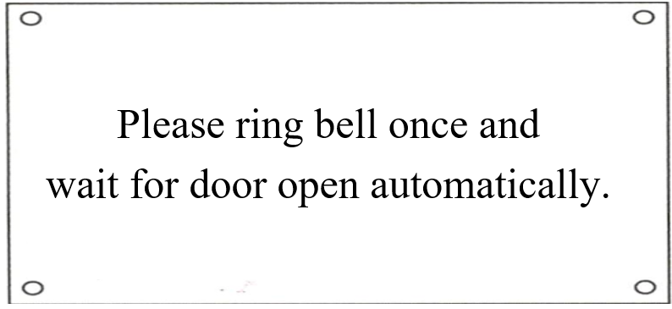 | 28. What does the sign say?  A. Someone will open the door when you ring the bell.  B. The door will open after you ring the bell.  C. You can open the door after ringing the bell.  D. The door will open before you ring the bell.
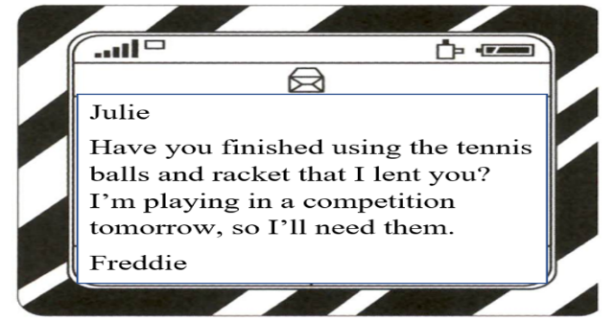 | 29. Freddie wants Julie _________.  A. to give him some advice about tennis  B. to play tennis with him tomorrow  C. to return his sports equipment  D. to join the tennis competition with him
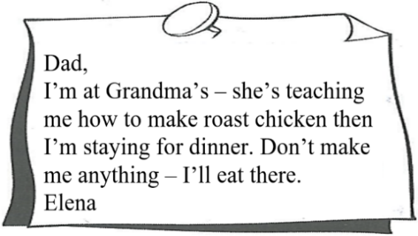 | 30. Elena has written this note _________.  A. to tell her dad about her dinner plans  B. to ask if her dad likes roast chicken  C. to check where her dad is having dinner  D. to remind her dad to make dinner for her

II. WRITING (2.5 points)
Rewrite the second sentence so that it has a similar meaning to the original one, beginning with the given word(s).
31. We look after the neighbours’ cat while they're away.
→ We take
32. My sister doesn’t have a smartphone and she’d like to have one.
→ My sister wishes
33. My mother asked me, “Are you coming to the dance class this afternoon?”
→ My mother asked me
34. The weather was so awful that we had to cancel our trip to the mountains.
→ It was such
Order the words to make complete sentences.
35. teenagers. / an excellent way / Setting goals / to / motivate / is/
36. what / on / understanding / sleep, / Based / for. / we/ a rich / ask / sleep / is /good/ of/ no/ longer/ have/ to /
37. In 100–120 words, write a paragraph about how to keep fit in your daily life. You can use the following questions as cues or your own ideas.

- What do you often do to keep fit?

- What food and drinks do you usually have?

- Do you get enough sleep?

- How often do you take part in outdoor activities?

--- The end ---

